1. Log onto <https://repo.continuum.io> to access installers. Choose **Miniconda Installers**, as it best serves the purpose.

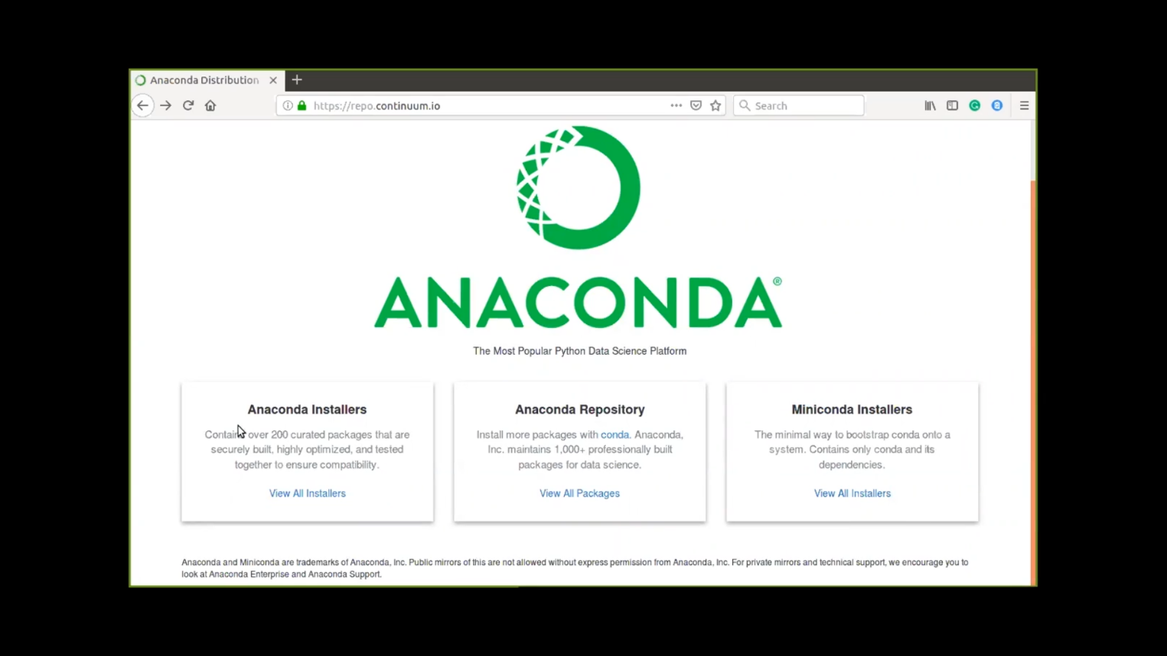  
B) Download **Miniconda3-latest-MacOSX-x86_64.sh** file

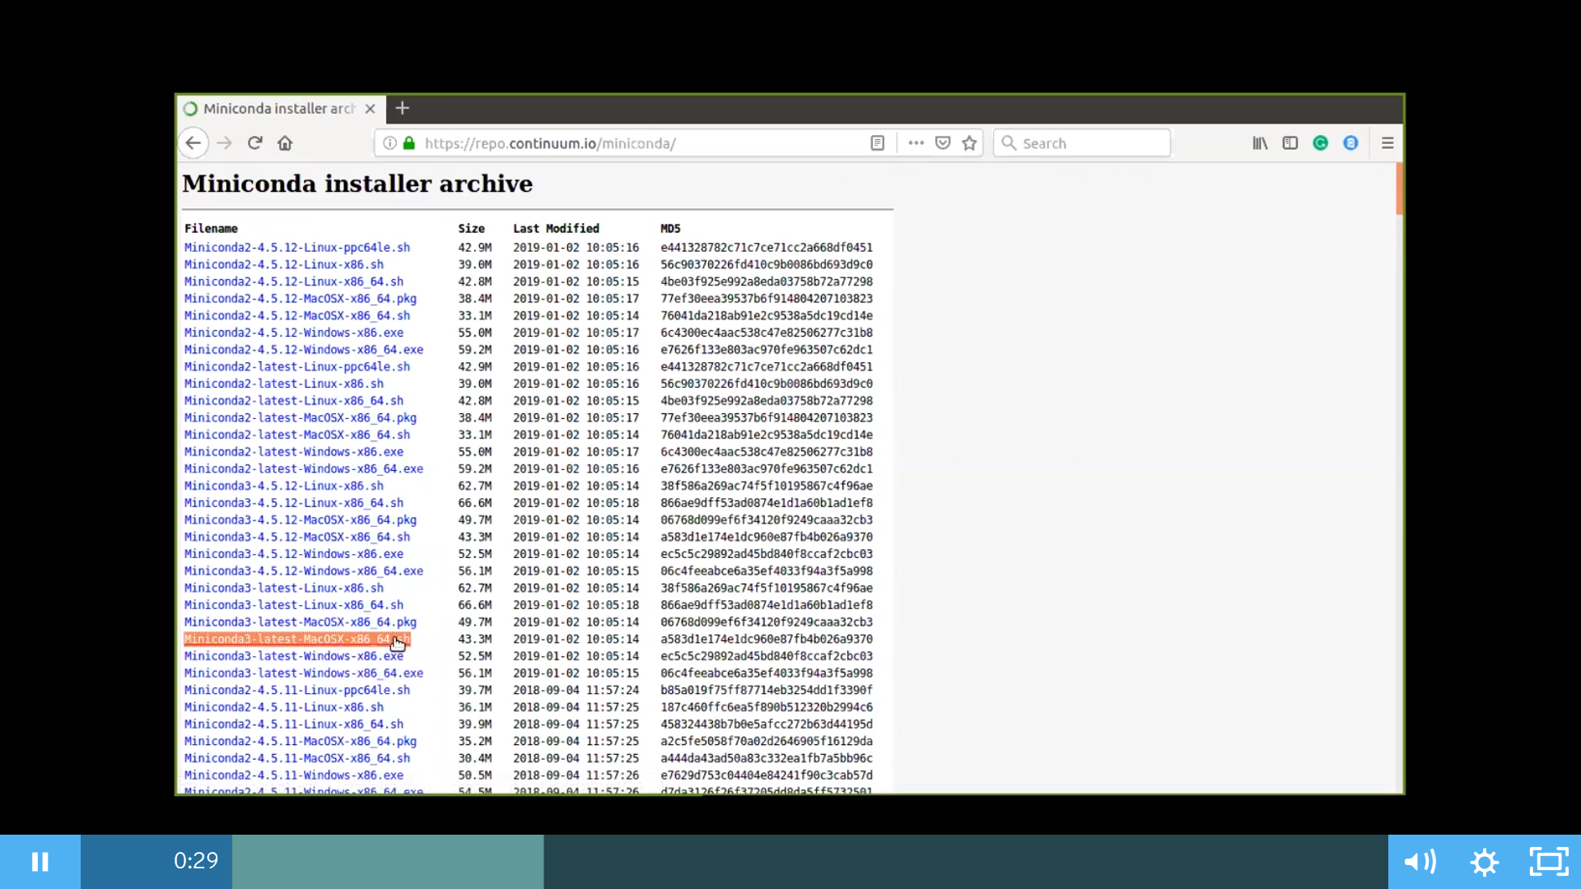

1. Find the anaconda installer file in the download folder

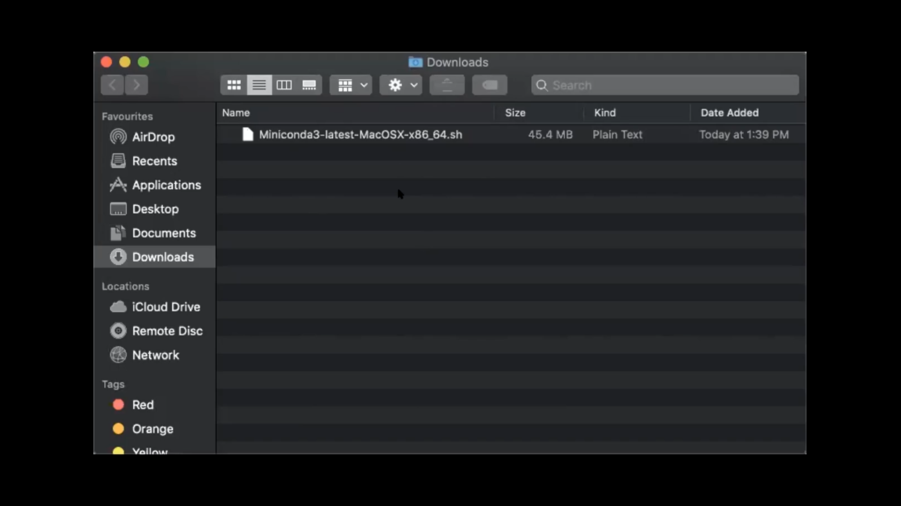

1. Use the below command to access the location where file is downloaded

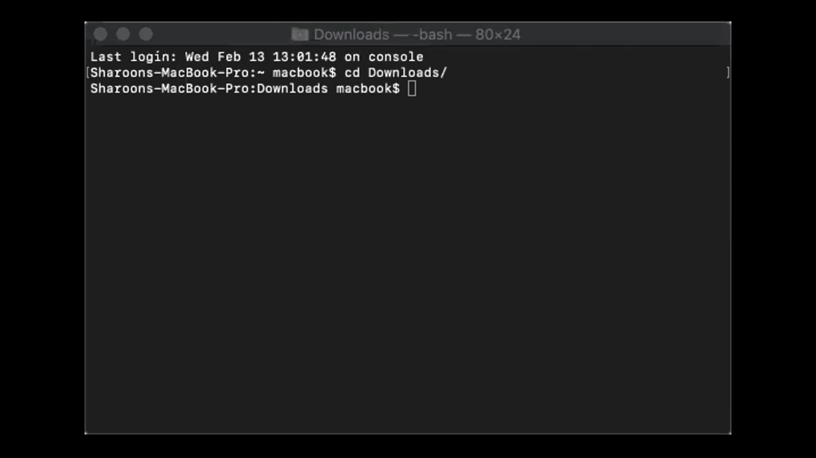

E) Type the full path to select the anaconda installer

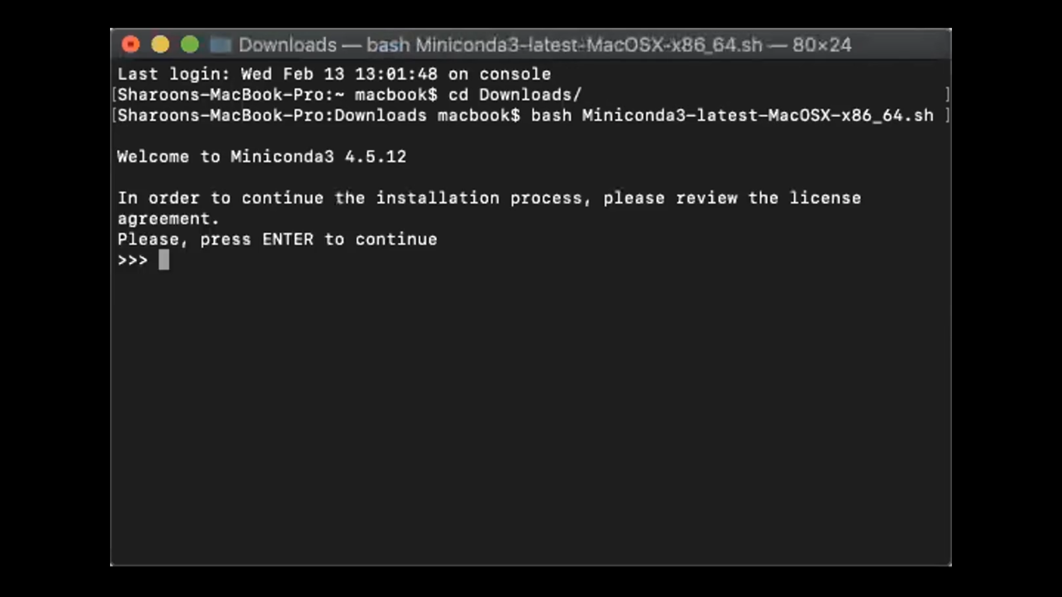

F) Press **“enter”** to continue



G) Keep pressing “**enter**” to get through the license content. To conclude, type “**yes**” to the question asked

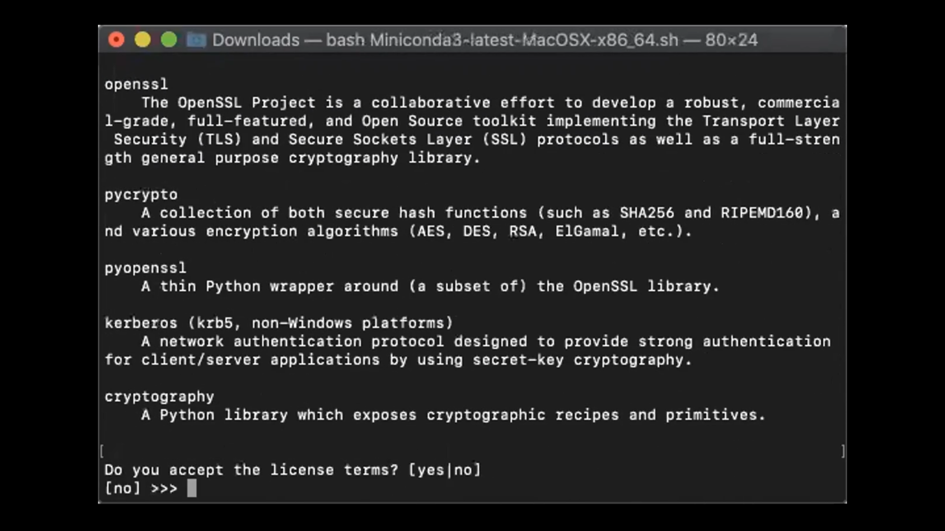

H) Press **“enter”** to confirm the location

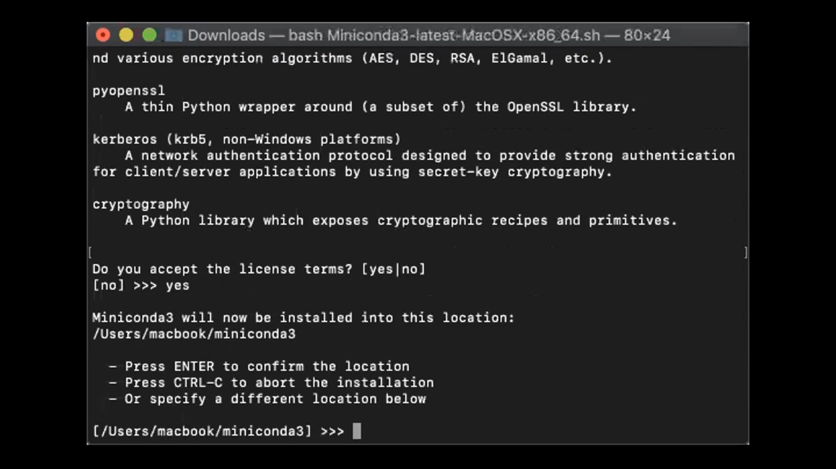

I) Type “**yes**” to initiate the installation

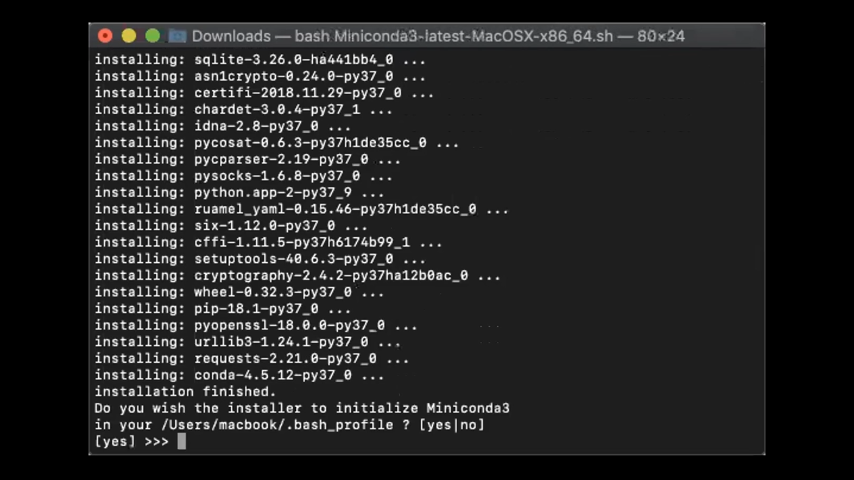

J) Open up New terminal to create new environment

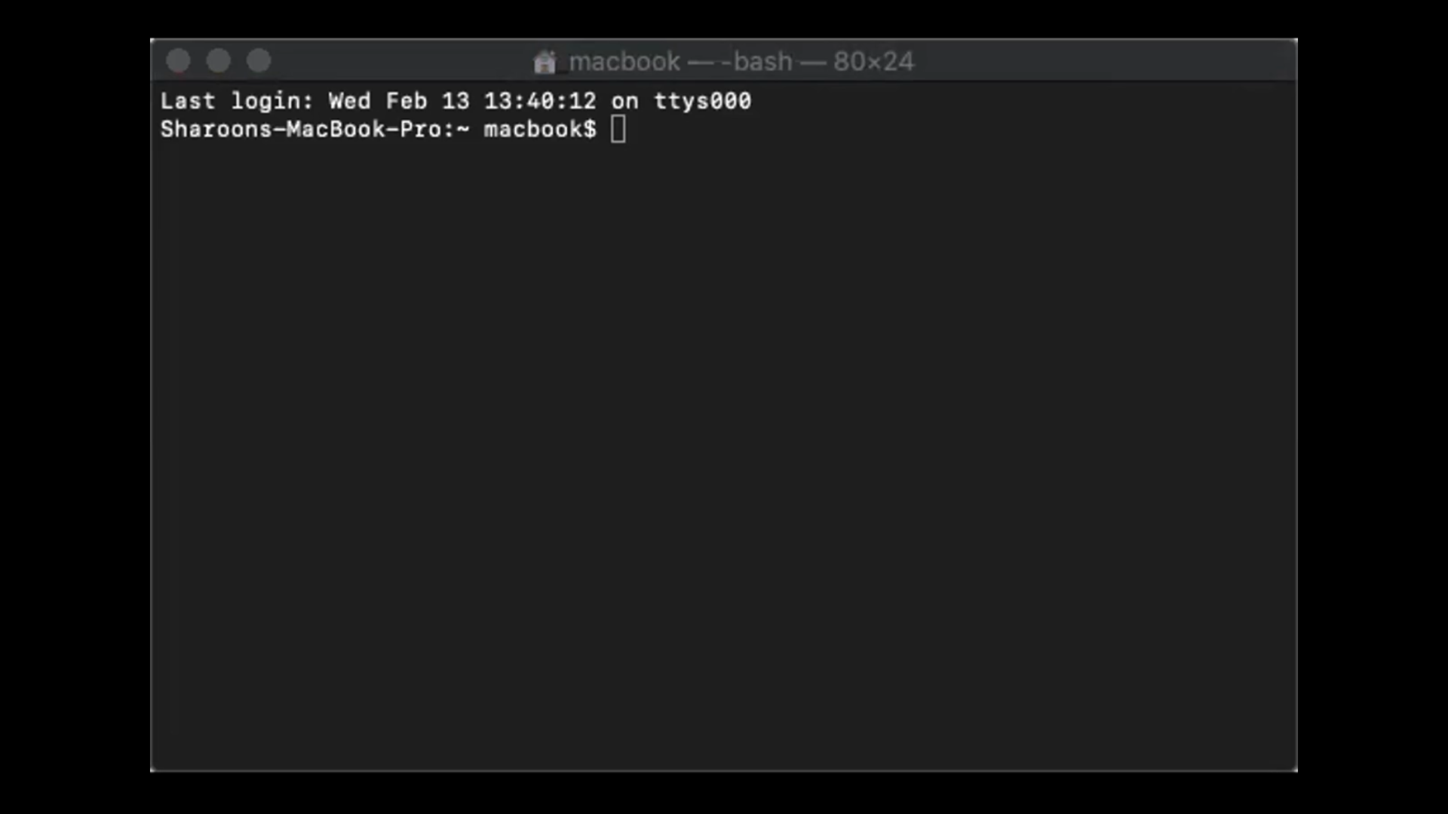

K) Type the below command to create new environment

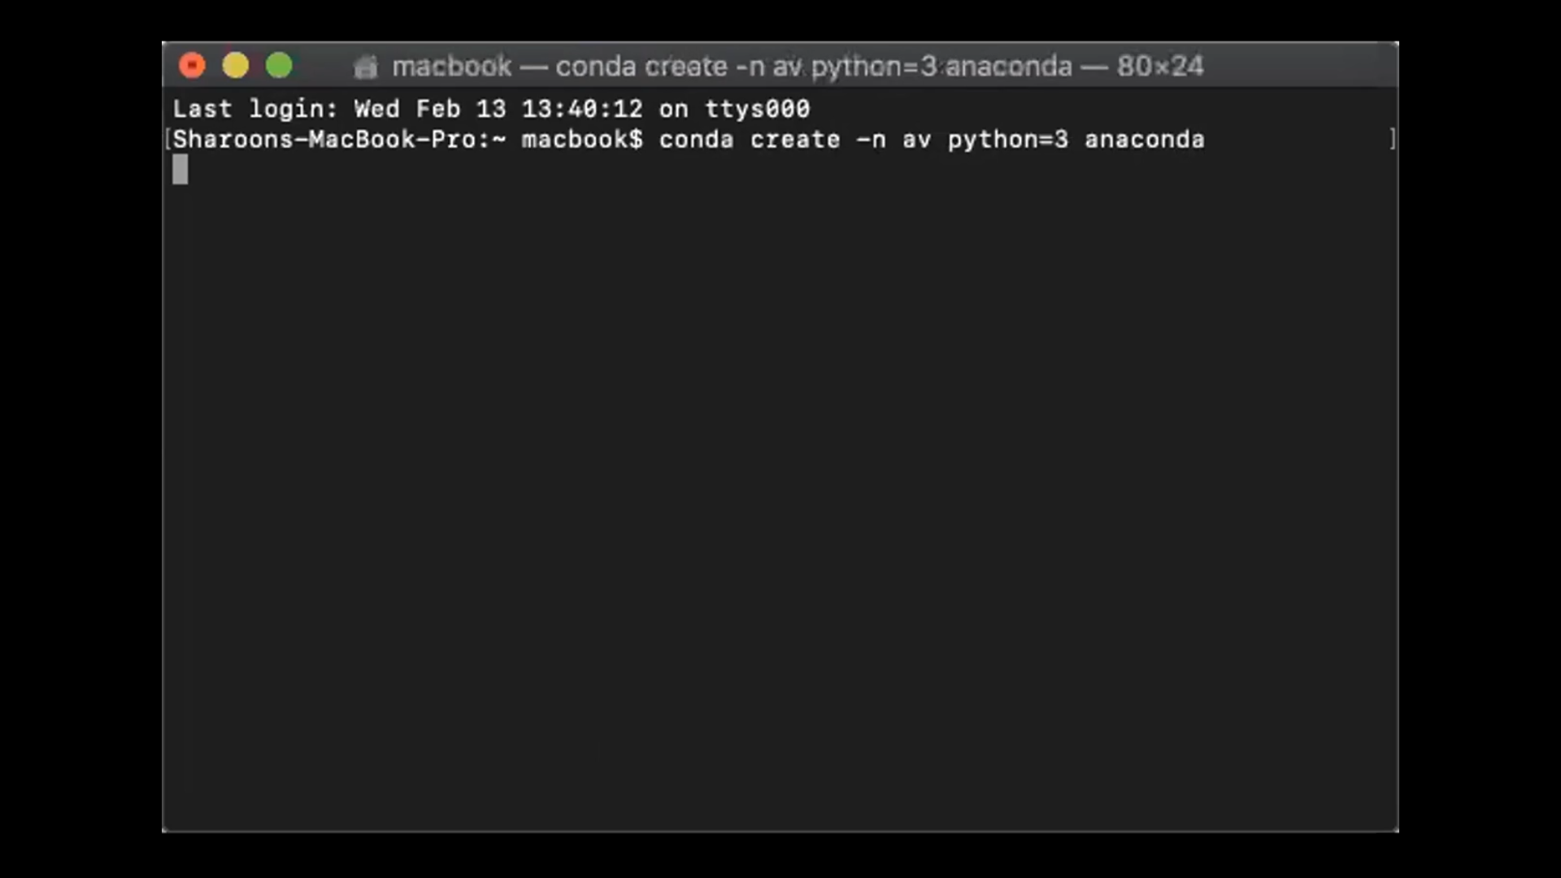

L) Press **“y”** to accept the installation

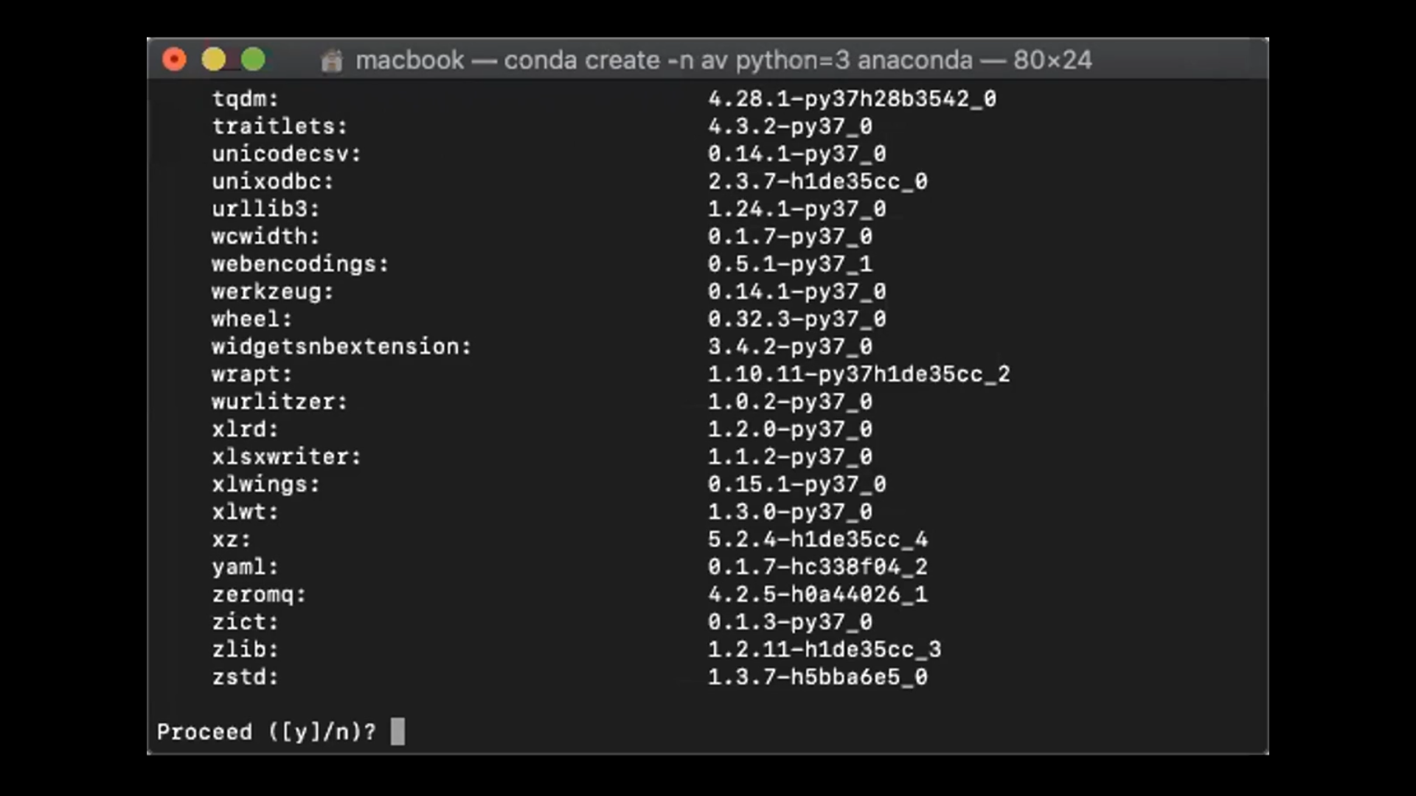

M) Type the below command to confirm if the environment is created

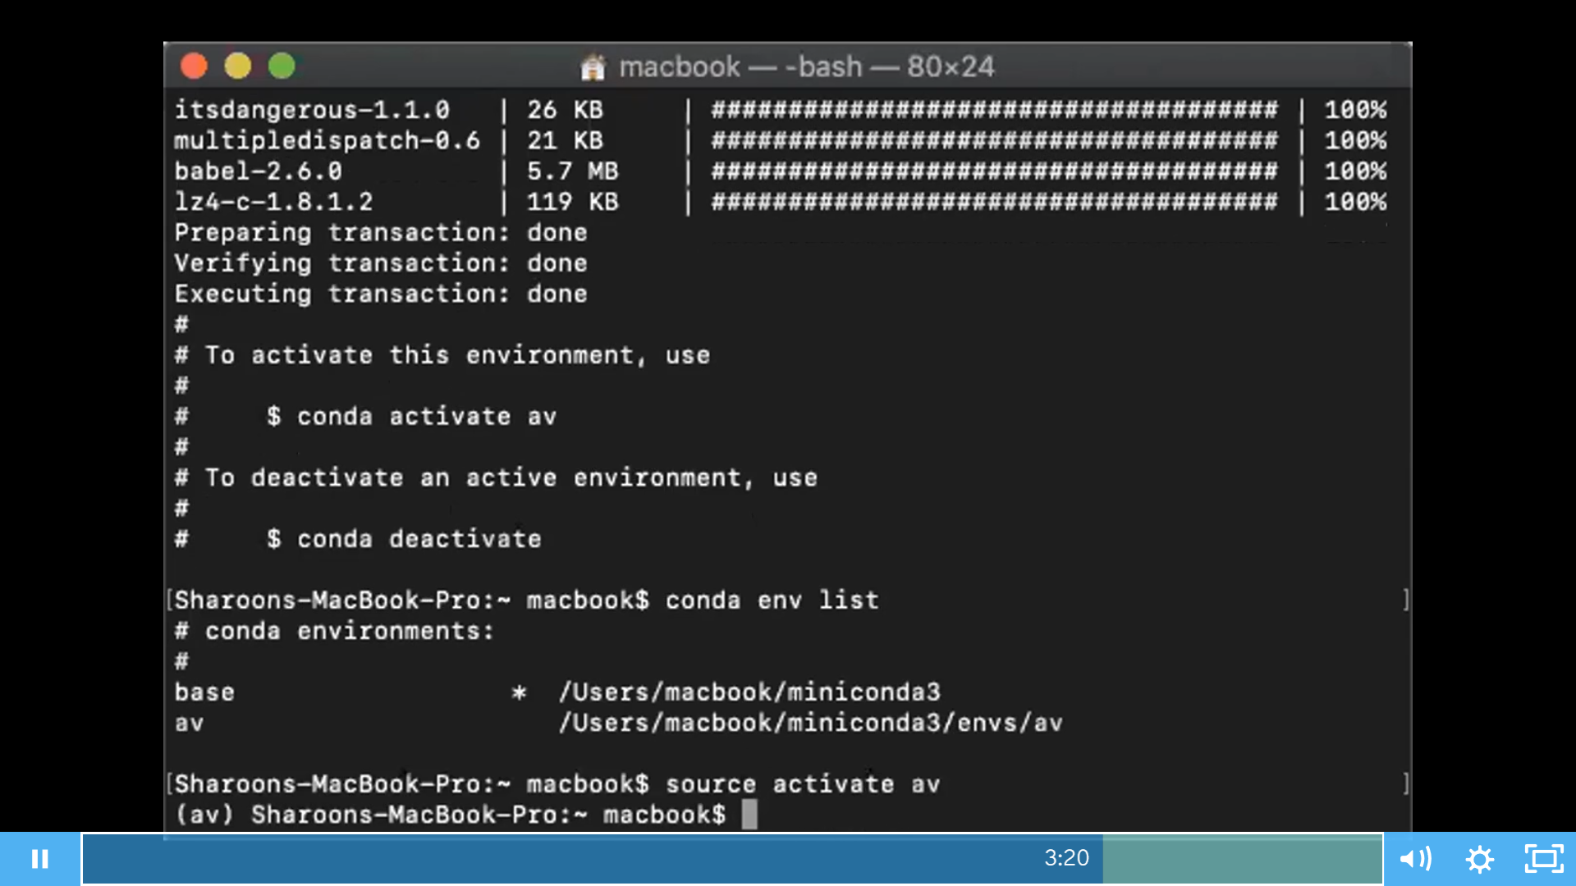

N) Type the below command to start working on the new environment

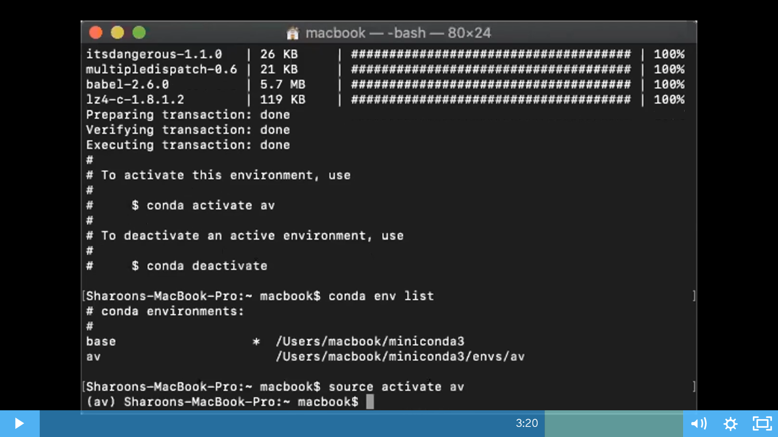

O) Use the below command to exit the environment

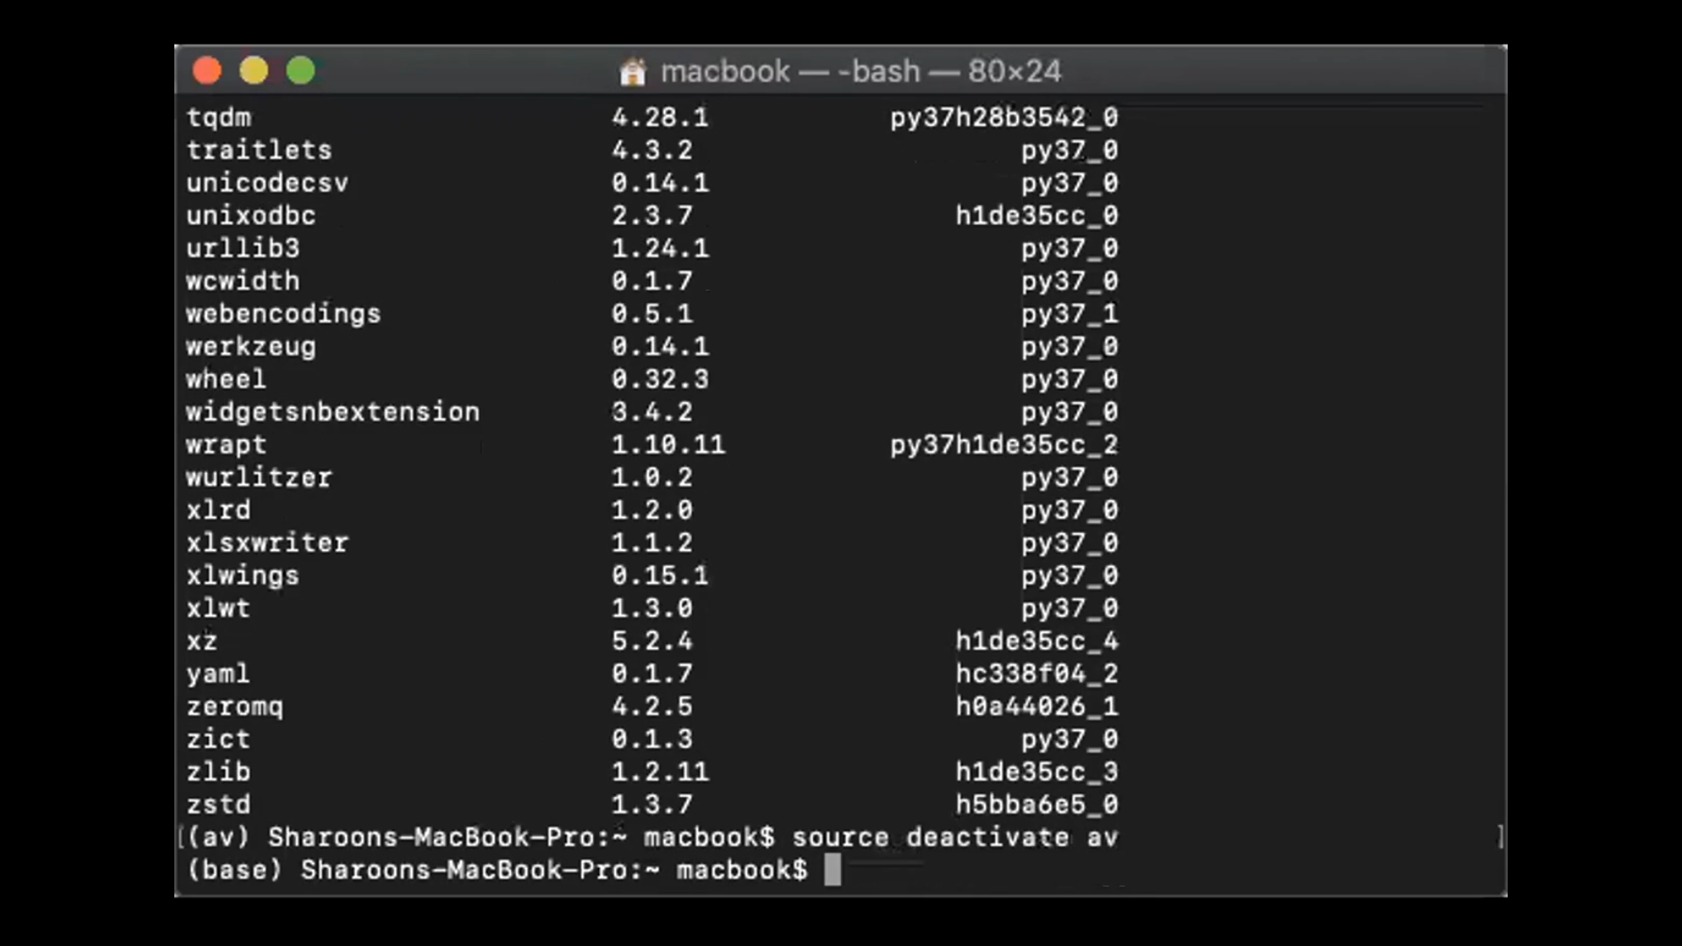

P) To get started with programming, use a new bash window and type the below command to activate jupyter notebook

